Contents

Introduction 1

Architecture 2

Web Application 3

Progressive Web Application 4

Android App 4

Database 6

User, Role and Permission 7

Monitoring Framework, Budget and Target 8

Beneficiary and Locations 9

Schedules and Instances 10

Beneficiary 11

Facility 12

# Introduction

Cox’s Bazar Education Sector EMIS is a complete solution to manage information of Rohingya children and facilities. System also manage education sector partners, programming partners, implementation partners and teachers. The ESP users create beneficiaries (Rohingya), create facilities, schedule beneficiary and facility data collection instance, execute data collection process, approve collected records and generate several reports based on filters.

# Architecture



**Operating System:** Ubuntu 18.04.4 LTS (GNU/Linux 4.15.0-126-generic x86_64)

**Packages:**

* dotnet-sdk-3.1
* aspnetcore-runtime-3.1
* nginx
* MySQL 8.0.21

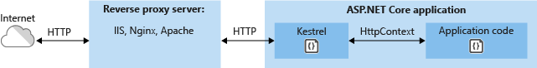Nginx has been used as the reverse proxy server.

## Web Application



HTTP Request goes from angular 7 UI to Microsoft.AspNetCore.Mvc.ControllerBase. The Controller forward the call to service/business layer to perform the operation. The service layer contains all the business logics and perform operations using repository layer. The repository layer uses Entity Framework Core to access MySQL database.

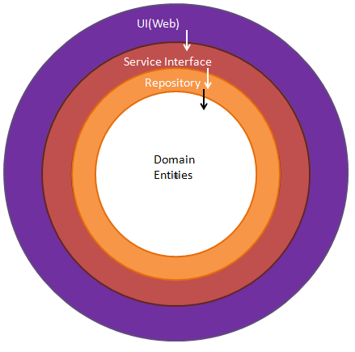

Onion architecture

## Progressive Web Application

To support offline data collection at other devices (laptop, desktop), a progressive web application has been developed. It has been developed using angular 7 along with IndexedDB as storage. The application supposed to run at any latest browser.

## Android App

The android application has been developed using following configurations:

|  |  |
| --- | --- |
| Application Id | com.unicefeducation.mis |
| Minimum SDK Version | 21 |
| Target SDK Version | 29 |

Android Jetpack architectural components has been used.

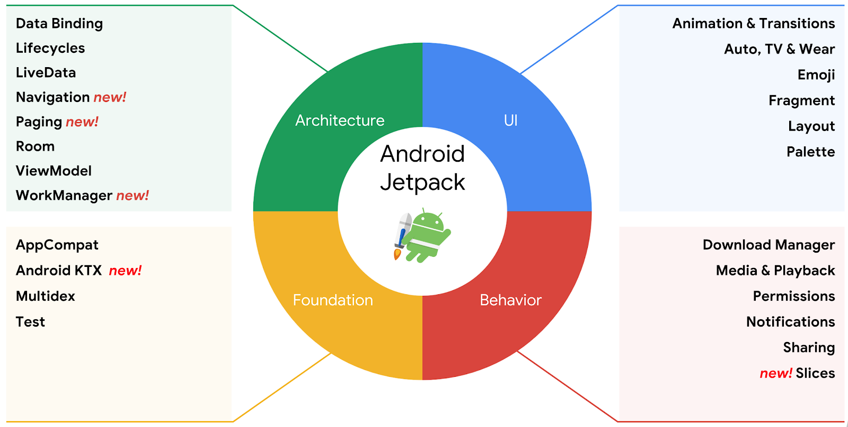

Android App architecture:

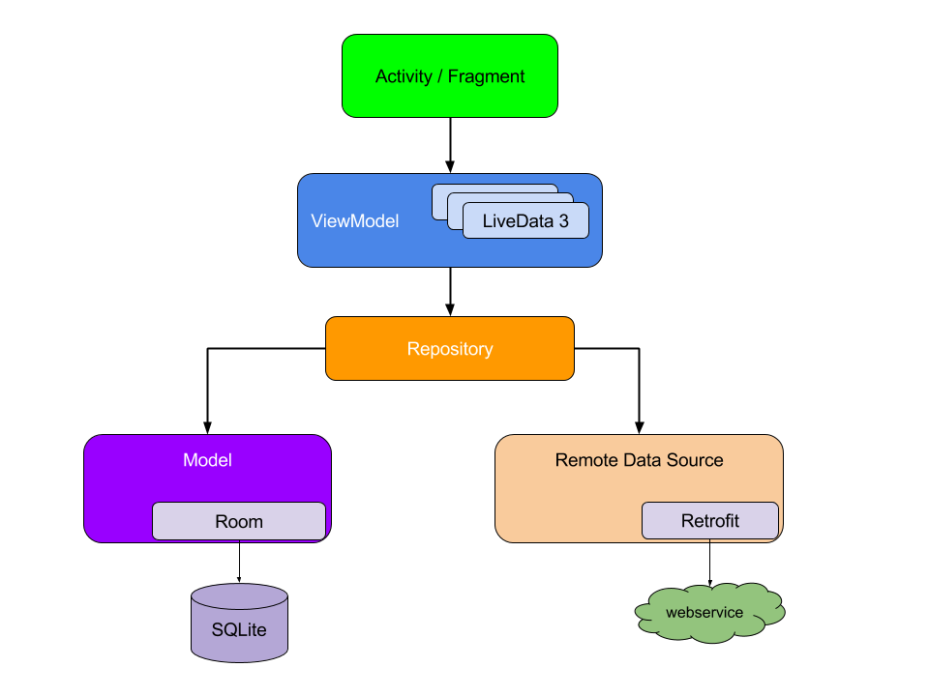

# Database

Database diagrams are presented below part by part.

## User, Role and Permission

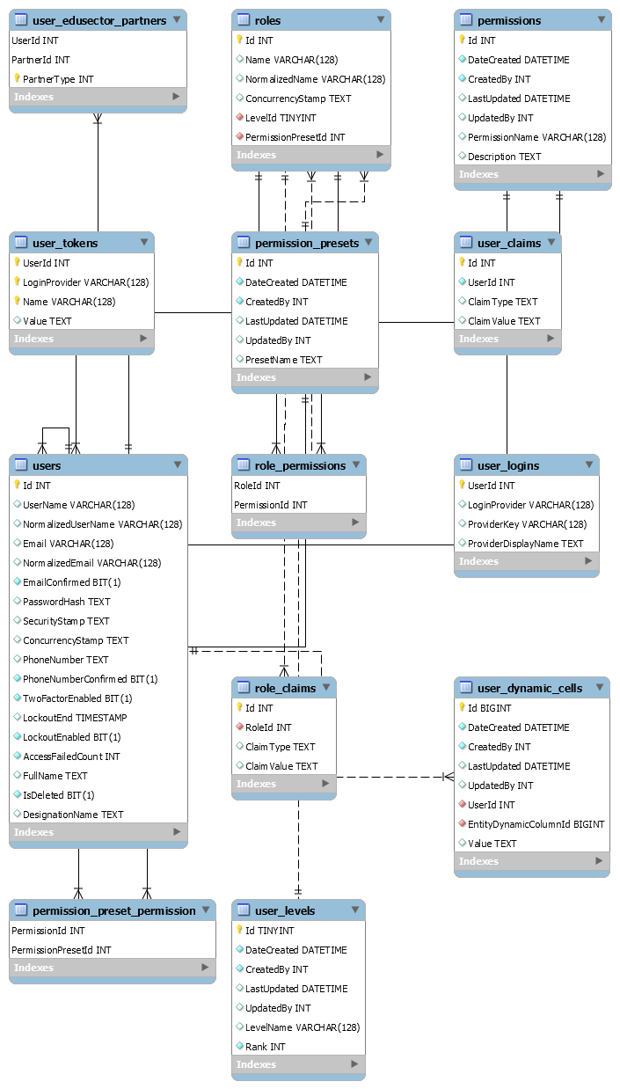

## Monitoring Framework, Budget and Target

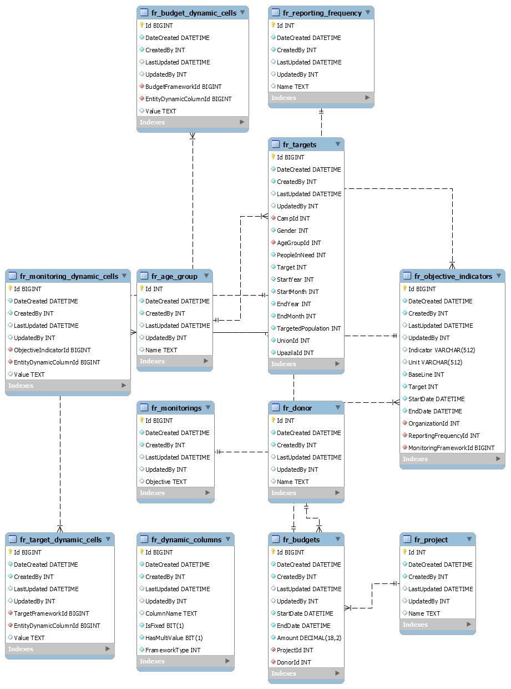

## Beneficiary and Locations

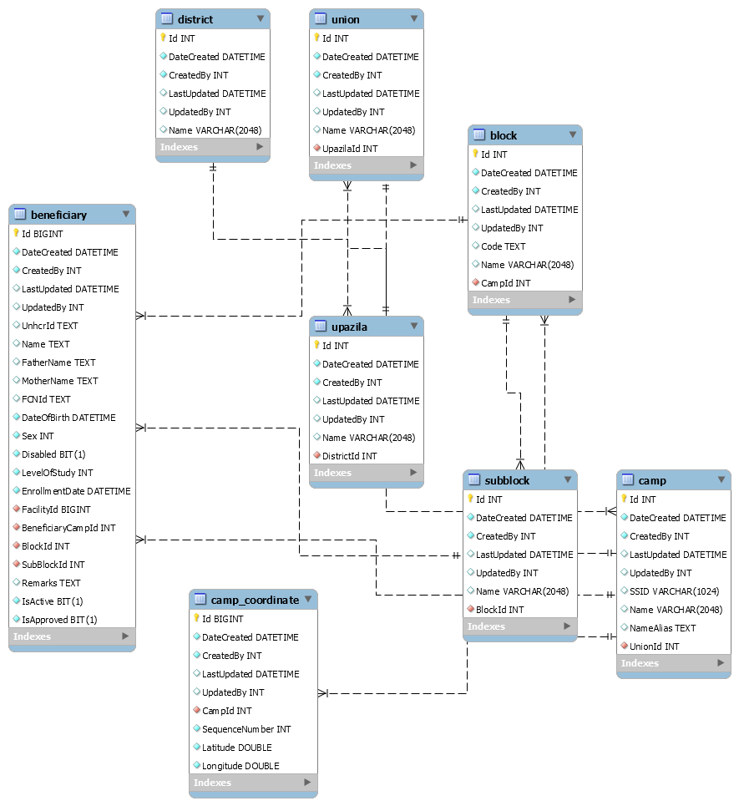

## Schedules and Instances

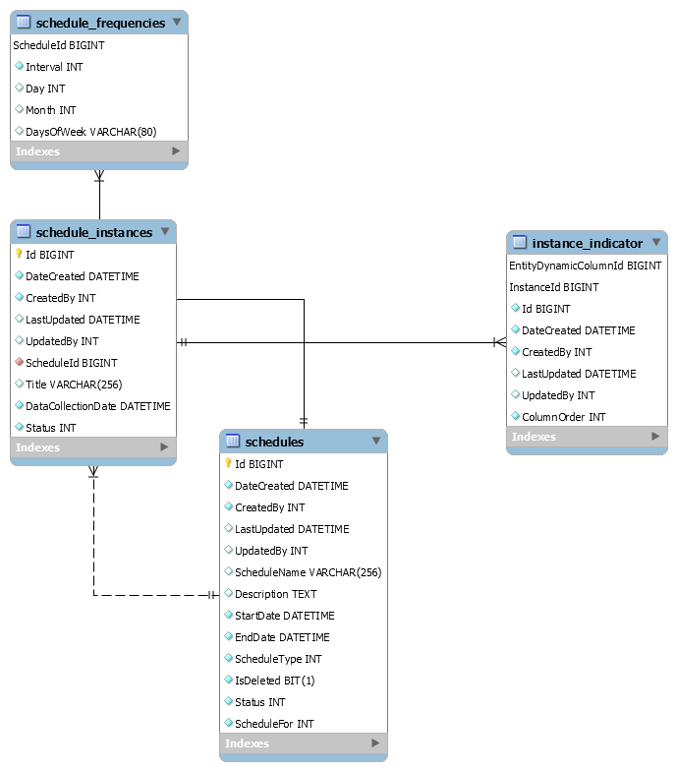

## Beneficiary

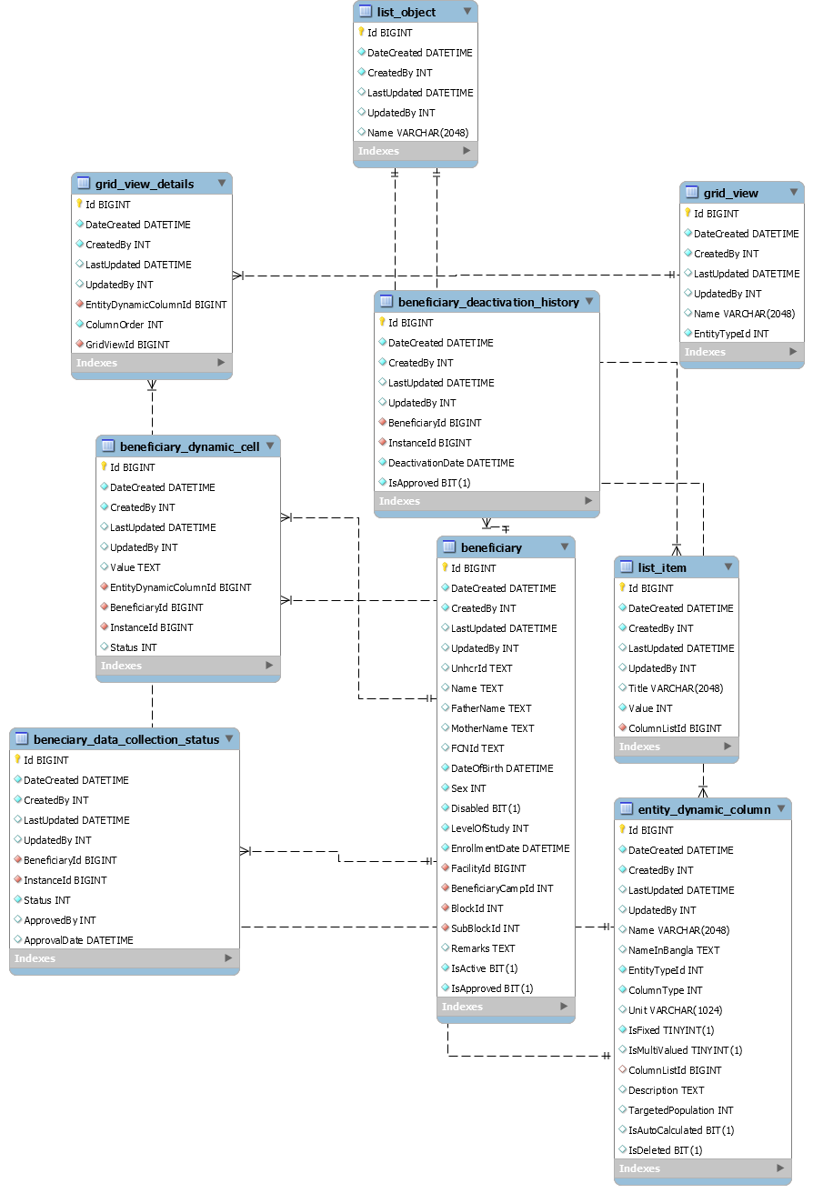

## Facility

